## Institute Vision, Mission Statements

#### Vision

* To emerge as a centre of technical excellence, transforming the engineering aspirants into dynamic and socially responsible technocrats

#### Mission

* **IM1:** Implementing effective strategies for imparting quality education in a conducive academic ambience to upgrade the intellectual and professional dimensions of the learner’s personality
* **IM2:** Facilitating skill development and research to fulfill societal needs
* **IM3:** Inculcating moral principles, environmental consciousness and social responsibility among Students
* **IM4:** Grooming the students to handle the career challenges successfully

## Department of Computer Science & Engineering

#### Vision

* To evolve as a leading computer science and engineering center producing competent technocrats to meet the demands of ever-changing industry and society

#### Mission

* Impart quality education through innovative teaching learning processes
* Motivate the learners to upgrade technical expertise by promoting learner centric activities.
* Inculcate values and interpersonal skills in the learners towards overall development.
* Upgrade knowledge in cutting edge technologies keeping pace with industrial standards through collaborations.

##### **EDGE BLOCKCHAIN BASED SECURE DATA SHARING SCHEME FOR IoT ENVIRONMENTS**

##### A Project Report Submitted to

**JAWAHARLAL NEHRU TECHNOLOGICAL UNIVERSITY, ANANTAPUR**

##### Submitted By

|  |
| --- |
| **T. SRI SAI HARSHINI** |
| **(212U1A05B2)** |

|  |  |  |
| --- | --- | --- |
| **T. NAVYA DURGA** | **SK. REEHA SHAD** | **S. LAKSHMI SRI MODHINI** |
| (**212U1A05B4)** | **(212U1A0598)** | **(212U1A05A9)** |

Under the Esteemed Guidance of

###### N. SIVA NAGAMANI

Associate Professor

Department of Computer Science & Engineering

***Project report submitted in partial fulfillment of the***

***Requirements for the award of the degree of***

**BACHELOR OF TECHNOLOGY**

**IN**

**COMPUTER SCIENCE AND ENGINEERING**



**DEPARTMENT OF COMPUTER SCIENCE & ENGINEERING**

**GEETHANJALI INSTITUTE OF SCIENCE AND TECHNOLOGY**

**A Unit of USHODAYA EDUCATIONAL SOCIETY**

***(Approved by AICTE, New Delhi & Permanently Affiliated to JNTUA, Anantapuram)***

**NAAC ‘A’ Grade Accredited Institution, An ISO 9001:2015 certified Institution**

**Recognized under Sec. 2(f) & 12(B) of UGC Act,1956**

3rd Mile, Bombay Highway, Gangavaram (V), Kovur(M), SPSR Nellore (Dt), Andhra Pradesh, India- 524137

Ph No. 08622-212769, E-Mail: geethanjali@gist.edu.in, Web[site:](http://www.gist.edu.in/) [www.gist.edu.in](http://www.gist.edu.in/)



Website [:](http://www.gist.edu.in/) [www.gist.edu.in](http://www.gist.edu.in/) Ph : 0862-212781

Email: [csehod@gist.edu.in](mailto:csehod@gist.edu.in) Fax: 08622-212778

**GEETHANJALI INSTITUTE OF SCIENCE AND TECHNOLOGY**

###### A Unit of USHODAYA EDUCATIONAL SOCIETY

***(Approved by AICTE, New Delhi & Permanently Affiliated to JNTUA, Anantapuramu)***

**NAAC ‘A’ Grade Accredited Institution, An ISO 9001:2015 certified Institution Recognized under Sec. 2(f) & 12(B) of UGC Act, 1956**

3rd Mile, Bombay Highway, Gangavaram (V), Kovur(M), SPSR Nellore (Dt), Andhra Pradesh, India- 524137

**BONAFIDE CERTIFICATE**

This is to certify that the project work entitled “**EDGE BLOCKCHAIN BASED SECURE DATA SHARING SCHEME FOR IOT ENVIRONMENTS”** is a bonafide record done by T.SRI SAI HARSHINI (212U1A05B2), T.NAVYA DURGA (212U1A05B4), SK.REEHA SHAD (212U1A0598), S.LAKSHMI SRI MODHINI (212U1A05A9) in the department of **Computer Science & Engineering, Geethanjali Institute of Science and Technology, Nellore** and is submitted to Jawaharlal Nehru Technological University, Anantapur in the partial fulfilment for the award of **B. Tech degree in Computer Science & Engineering.** This work has been carried out under my supervision.

###### N. SIVA NAGAMANI Dr.V.GAYATRI

Associate Professor HOD

Department of CSE Department of CSE

GIST, NELLORE GIST, NELLORE

###### Submitted for the Viva-Voce Examination held on

**Internal Examiner External Examiner**

**ACKNOWLEDGEMENTS**

The satisfaction that accompanies the successful completion of the project would be incomplete without the people who made it possible. Their constant guidance and encouragement crowned the efforts with success.

We express our deepest sense of gratitude to **Sri. N. SUDHAKAR REDDY Garu, Secretary and Correspondent**, Geethanjali Institute of Science and Technology, Nellore and other members of Management for providing all the facilities needed for this work.

We owe our gratitude to **Dr. G. SUBBA RAO, Director,** Geethanjali Institute of Science and Technology, Nellore, for his consistent help and valuable suggestions.

We express our sincere thanks to the honourable Principal **Dr. SUNDEEP KUMAR K, Principal,** Geethanjali Institute of Science and Technology, Nellore, for his consistent help and valuable suggestions.

Our special thanks to **Dr. V. GAYATRI, Head of The Department,** Department of Computer Science & Engineering, Geethanjali Institute of Science and Technology, Nellore, for her timely suggestions and help during the progress of project work in spite of her busy schedule.

It is indeed our proud privilege to express our deep sense of gratitude and indebtedness to our guide, **N. SIVA NAGAMANI, Associate** **Professor,** Computer Science & Engineering***,*** Geethanjali Institute of Science and Technology, Nellore, for her keen interest, critical, constructive and skillful guidance and constant encouragement throughout the course and for successful completion of project.

During the entire course of dissertation work, we received valuable academic inputs as well as moral support from other departments, general teaching and non-teaching faculty **GEETHANJALI INSTITUTE OF SCIENCE AND TECHNOLOGY**, Nellore.

We were motivated by the uphold and moral encouragement given to us by our beloved parents. Finally we wish to express our sincere thanks for all those who helped me directly or indirectly to complete the work.

**PROJECT ASSOCIATES**

**T. SRI SAI HARSHINI (212U1A05B2)**

**T. NAVYA DURGA (212U1A05B4)**

**SK. REEHA SHAD (212U1A0598)**

**S. LAKSHMI SRI MODHINI (212U1A05A9)**

**TABLE OF CONTENT**

**ABSTRACT i**

**LIST OF FIGURES ii**

**LIST OF ABBREVATIONS iii**

|  |  |  |
| --- | --- | --- |
| **S.NO** | **CONTENTS** | **PAGE NO** |
| **1.** | **INTRODUCTION** | **1** |
|  | 1.1 Overview | 2 |
|  | 1.2 Motivation | 2 |
|  | 1.3 About IoT | 3 |
|  | 1.4 IoT Enablers | 4 |
|  | 1.5 How IoT Works | 4 |
|  | 1.6 Data Collection in IoT Devices | 5 |
|  | 1.7 Objective | 6 |

1. **LITERATURE SURVEY 7**
2. SYSTEM ANALYSIS 10
   1. Existing System 11
      1. Disadvantages of Existing Systems 11
   2. Proposed System 12
      1. Advantages of Proposed System 12
   3. System Study 12
   4. Feasibility Study 13
      1. Types of Feasibility Study 13
3. METHODOLOGY 15
   1. System Architecture 16

* 1. Working Process of Modules 17

1. SYSTEM REQUIREMENTS AND 19

SPECIFICATIONS

* 1. Hardware Requirements 20
  2. Software Requirements 20
     1. Python 20
     2. Python Interpreter 21
     3. History of python 21
     4. Features of python 21
     5. Python Libraries 22
     6. MySQL 23
     7. Key Features of MySQL 23
     8. How MySQL Works 23

1. SYSTEM DESIGN 25
   1. UML Diagrams 26
      1. Sequence diagram 27
      2. Class diagram 28
      3. Activity diagram 29
2. SYSTEM IMPLEMENTATION 31
   1. System Modules 32
3. TESTING 34
   1. Introduction to System Testing 35
   2. Types of System Testing 35
      1. Functional Testing 35
      2. Compatibility Testing 35
      3. Performance Testing 36
      4. Connectivity Testing 36
      5. Security Testing 36
      6. Usability Testing 37

8.3 Test Cases 37

1. RESULTS 38
2. CONCLUSION 49
3. FUTURE SCOPE 51
4. BIBLIOGRAPHY 53

**ABSTARCT**

This project introduces an Edge Based Blockchain Secure Data Sharing Scheme (EB-SDSS) to improve the efficiency and security of data exchange between IoT devices, edge servers, and cloud servers. Traditional cloud-based systems face issues like high latency and security vulnerabilities, which this scheme aims to overcome. By using edge servers, data from IoT devices is processed closer to the source, reducing transfer times. Blockchain technology ensures data integrity and prevents tampering through hash-based transactions. For security purpose, AES encryption is used which protects the data, while Local Sensitive Hashing (LSH) allows for quick and efficient searches of Blockchain-stored IoT data. To verify the authenticity of devices and shared data, the system uses a certificate-less signature scheme, and Shamir’s secret sharing enhances cryptographic key security. Additionally, two key enhancements are introduced. Elliptic Curve Cryptography (ECC) for more efficient encryption. Cache memory to speed up LSH search operations, reducing redundant queries. This approach not only strengthens the security of IoT data sharing but also enhances efficiency, making IoT applications more responsive and resilient across different industries.

**LIST OF FIGURES**

|  |  |  |  |
| --- | --- | --- | --- |
| **S.NO** | **FIGURE NO** | **FIGURE NAME** | **PAGE NO.** |
| 1. | 1.1 | IoT Sensor Architecture | 5 |
| 2. | 3.4.1 | Feasibility Study | 14 |
| 3. | 4.1 | System Architecture | 16 |
| 4. | 4.2.1 | Table Of Modules | 19 |
| 5. | 4.1 | System Architecture | 18 |
| 6. | 5.2.8.1 | Working Process of MySQL | 25 |
| 7. | 6.1.1 | Sequence Diagram | 29 |
| 8. | 6.1.2 | Class Diagram | 30 |
| 9. | 6.1.3 | Activity Diagram | 31 |

**LIST OF ABBREVATIONS**

**SNO ACRONYM ABBREVATIONS**

1. IoT Internet of Things
2. LSH Locality Sensitive Hashing
3. AES Advanced Encryption Hashing
4. ECC Elliptic Curve Cryptography
5. RFID Radio-frequency identification
6. UML Unified Modelling Language



# CHAPTER - 1 INTRODUCTION



## INTRODUCTION

## 1.1 OVERVIEW

Current data sharing mechanisms lead to data silos, which inhibit the potential benefits of IoT systems and create reliance on cloud computing, resulting in network congestion and degraded Quality of Experience. The IoT can be vulnerable to corruption.

Protecting the data mined by IoT devices can be challenging, and increased tracking threatens the confidentiality of shared information. The IoT can be complex. In the following section we will develop an efficient and secure data sharing mechanism utilizing edge computing and blockchain technology to ensure local data processing, user privacy, and data integrity, fostering trust among participants

In the following section we will develop an efficient and secure data-sharing mechanism utilizing edge computing and blockchain technology to ensure local data processing, user privacy, and data integrity, fostering trust among participants.

**1.2 MOTIVATION**

The motivation behind this project stems from the urgent need to safeguard our digital secure data-sharing mechanism for IoT devices, edge servers, and cloud servers, ensuring the protection of sensitive information through AES symmetric encryption to prevent unauthorized access and tampering.

In this advanced automation and analytics system networking, sensing, big data, and artificial intelligence technology to deliver complete systems for a product or service. These systems allow greater transparency, control, and performance when applied to any industry or system.

IoT systems have applications across industries through their unique flexibility and ability to be suitable in any environment. They enhance data collection, automation, operations, and much more through smart devices and powerful enabling technology.



It is reasonable to think that this long time of effective production is probably due to issues of implementation and security. However, as with any form of data exchange, the issue of security is present and it is essential to look for good solutions for digital security.

### ABOUT IoT

Internet of Things (IoT) refers to the interconnectedness of physical devices, such as appliances and vehicles, that are embedded with software, sensors, and connectivity which enables these objects to connect and exchange data. This technology allows for the collection and sharing of data from a vast network of devices, creating opportunities for more efficient and automated systems.

The networking of physical objects that contain electronics embedded within their architecture in order to communicate and sense interactions amongst each other or with respect to the external environment. In the upcoming years, IoT-based technology will offer advanced levels of services and practically change the way people lead their daily lives. Advancements in medicine, power, gene therapies, agriculture, smart cities, and smart homes are just a few of the categorical examples where IoT is strongly established.

IoT is a system of interrelated things, computing devices, mechanical and digital machines, objects, animals, or people that are provided with unique identifiers. And the ability to transfer the data over a network requiring human-to-human or human-to-computer interaction.The Internet of Things (IoT) encompasses a wide range of applications, including smart cities, transportation, healthcare, and energy management, significantly enhancing user experiences and services.

Effective data sharing among IoT devices enhances contextual understanding, facilitating coordinated actions and intelligent decision-making. Issues such as lack of trust, data tampering, unauthorized access, and privacy concerns hinder effective data sharing, leading to data silos and impeding IoT development. The incorporation of blockchain technology into data sharing schemes provides a tamper-proof and transparent framework, ensuring data integrity and authenticity while fostering trust among participants in the IoT ecosystem.



### IoT ENABLERS

### RFIDs: Radio-frequency identification uses radio waves in order to electronically track the tags attached to each physical object. These tags contain electronically stored information that can be read from several meters away, without requiring direct line of sight. RFID is commonly used in inventory management, asset tracking, access control, and supply chain logistics due to its efficiency and accuracy in tracking and managing items.

* **SENSORS:** A Sensor is a device that converts signals from one energy domain to electrical domain. Devices that are able to detect changes in an environment (ex: motion detectors).

### Edge: It is a distributed computing framework that brings computation and data storage closer to the location where it is needed, improving response times and saving bandwidth[1](https://www.bing.com/ck/a?!&&p=a2f49ec94a23667765287921c13e006358e70fc85f3fafc41e8623fb1e0b01d4JmltdHM9MTc0NDA3MDQwMA&ptn=3&ver=2&hsh=4&fclid=388651f3-ce6c-67c8-2cf9-4493cfca66d3&psq=edge+working+process+in+iot&u=a1aHR0cHM6Ly93d3cuZ2Vla3Nmb3JnZWVrcy5vcmcvZWRnZS1jb21wdXRpbmcv&ntb=1). In the context of the Internet of Things (IoT), edge computing allows data to be processed at the edge of the network, near the devices that generate the data.

* **Cloud:** It enables users to perform computing tasks using services provided over the Internet. Due to the rapid growth of technology, the problem of storing, processing, and accessing large amounts of data has arisen. Great innovation relates to the mutual use of the Internet of Things and cloud technologies.

### HOW IoT WORKS

### As mentioned before, IoT is a giant network consisting of interconnected devices. IoT devices have sensors embedded into them. These sensors are capable of sensing their surroundings. The devices store the information in some form of data. These devices include appliances such as mobile phones, coffee machines, microwaves, geysers, fire alarms, Air conditioners, cars and so on.



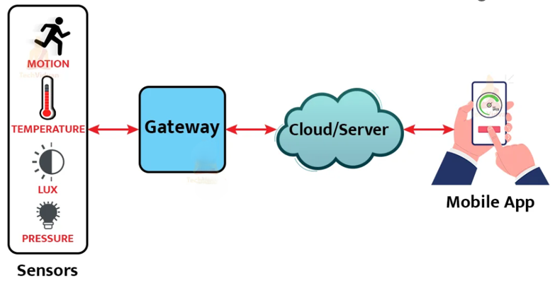

**Fig 1.1: IoT Sensor Architecture**

The sensors embedded in these devices constantly emit data about the surrounding and on the working information of these devices. IoT serves as a platform to dump all the data collected by these devices. IoT platform includes cloud servers and large databases. The IoT platform acts on the data. It integrates and processes the information. Further, the platform analyses the data thoroughly to gather important details. The platform then sends back instructions based on the data provided. Finally, the data aggregation is shared with other devices for better performance in the future. It is also done for improved user experience.

* 1. **DATA COLLECTION IN IoT DEVICES**

At this stage, users will receive the necessary data from the sensors, controlled devices, built in modules, etc., as part of our custom IoT software development services.

Besides, transmitting and sharing data among IoT devices via cloud may be insecure. To address these issues, efficient and secure data sharing scheme termed EB-SDSS (Edge Blockchain Secure Data Sharing Scheme) is proposed for edge-enabled IoT applications.

In this case, we may collect and store IoT data in two ways:

1. Data storage on a local or cloud server
2. Data storage on the IoT devices internal memory

Both data storage options are viable for different cases:

* In the first case, the device must be able to send data to the server immediately after collection. That is, there must be a stable connection with the server to transmit data in real time.
* In the second case, this approach is suitable if the device doesn’t have a permanent connection to the server. There also may be edge cases when the connection isn’t established. Under these conditions, the data needs to be saved and transferred to the server later.

**1.7 OBJECTIVE**

To establish a secure data-sharing mechanism for IoT devices, edge servers, and cloud servers, ensuring the protection of sensitive information through AES symmetric encryption to prevent unauthorized access and tampering. To enhance data integrity and authenticity, blockchain technology will be implemented, utilizing hash-based transactions to create tamper-proof records for verifiable data sharing. Additionally, the project aims to optimize data retrieval efficiency using Locality Sensitive Hashing (LSH) and cache memory to facilitate quick searches across blockchain-stored data. By leveraging edge computing, the project seeks to address latency and performance challenges while incorporating Elliptic Curve Cryptography (ECC) for added security.

**CHAPTER – 2 LITERATURE SURVEY**



1. **LITERATURE SURVEY**

**INTRODUCTION**

In this chapter will review some papers to get knowledge and understanding on the techniques had been proposed. It provides an overview of current knowledge, allowing us to identify relevant theories, methods, and gaps in the existing research. Allows us to understand the research journey from the fundamentals till date.

**Blockchain Assisted Secure Data Sharing Model for Internet of Things Based Smart Industries**

This research introduces the security requirement in smart industry data sharing through IoT, this article introduces a blockchain-assisted secure data sharing (BSDS) model. This model is responsible for administering inbound and outbound security in data acquisition and dissemination. The inbound acquisition is first classified using recurrent learning to identify adverse sequences in data dissemination. In the outbound security measure, end-to-end authentication based on the blockchain information of reputation and sequence differentiation is engaged.

**Blockchain Enhanced Data Sharing With Traceable and Direct Revocation in IoT**

This proposes the semi credibility nature of the IoT cloud platforms, how to achieve secure storage, access control, information update and deletion for smart factory data, as well as the tracking and revocation of malicious users has become an urgent problem. To solve these problems, a blockchain-enhanced security access control scheme has been proposed in IoT. The blockchain first performs unified identity authentication, and stores all public keys, user attribute sets, and revocation list. The system administrator then generates system parameters and issues private keys to users. The domain administrator is responsible for formulating domain security and privacy-protection policies, and performing encryption operations.



**Blockchain and Federated Learning for Privacy-Preserved Data Sharing in Industrial IoT**

Provides the information on security and privacy concerns (e.g., data leakage) are major obstacles for data providers to share their data in wireless networks. The leakage of private data can lead to serious issues beyond financial loss for the providers. In this article, we first design a blockchain empowered secure data sharing architecture for distributed multiple parties. Then, we formulate the data sharing problem into a machine-learning problem by incorporating privacy-preserved federated learning. The privacy of data is well-maintained by sharing the data model instead of revealing the actual data. Finally, we integrate federated learning in the consensus process of permissioned blockchain, so that the computing work for consensus can also be used for federated training. Numerical results derived from real-world datasets show that the proposed data sharing scheme achieves good accuracy, high efficiency, and enhanced security.

**Privacy Preserved Data Sharing Towards Multiple Parties in Industrial IoT**

This Article proposes a privacy-preserved data sharing framework for IoT, where multiple competing data consumers exist in different stages of the system. The framework allows data contributors to share their contents upon requests. The uploaded contents will be perturbed to preserve the sensitive status of contributors. The differential privacy is adopted in the perturbation to guarantee the privacy preservation. Then the data collector will process and relay contents with subsequent data consumers. This data collector will gain both its own data utility and extra profits in data relay. Two algorithms are proposed for data sharing in different scenarios, based on whether the service provider will further process the contents to retain its exclusive utility. This work also provides for both algorithms a comprehensive consideration on privacy, data utility, bandwidth efficiency, payment, and rationality for data sharing.



# CHAPTER – 3 SYSTEM ANALYSIS



## SYSTEM ANALYSIS

### EXISTING SYSTEM

* The existing system for the Secure Data Sharing Scheme primarily relies on traditional cloud-based mechanisms for IoT data sharing, which presents several limitations. It employs centralized data management, where IoT devices transmit data to centralized cloud servers for storage, processing, and sharing, consolidating control and access at a single point.
* While conventional security protocols, such as encryption and access control, are used to protect data during transmission and storage, they often lack advanced tamper-proofing features. Additionally, the reliance on cloud infrastructure results in limited real-time processing capabilities, leading to delays and high latency when accessing critical information from IoT devices. These challenges highlight the need for a more decentralized and secure approach to enhance data sharing and management in IoT environments.

**3.1.1 DISADVANTAGES OF EXISTING SYSTEM**

* The centralized nature of cloud services can result in significant delays in data transmission and retrieval, making it unsuitable for real-time applications that require immediate access to data.
* Centralized systems are more susceptible to data breaches, unauthorized access, and tampering, as a single point of failure can compromise the entire system's security, leading to potential data loss or exposure.
* As the number of IoT devices the volume of generated data increase, existing cloud-based systems struggle to scale effectively, resulting in poor performance and increased operational costs associated with data management and storage



### PROPOSED SYSTEM:

The proposed system is an Edge-based Blockchain Secure Data Sharing Scheme (EB-SDSS) that integrates edge computing and blockchain technology to provide secure and efficient data sharing between IoT devices, edge servers, and cloud servers. Blockchain is a decentralized, distributed ledger that records data in a tamper-proof, transparent manner, ensuring data integrity through hash-based transactions. The system employs AES symmetric encryption to secure data transmission and Local Sensitive Hashing (LSH) for efficient data retrieval. Additionally, Shamir’s secret sharing scheme is used to ensure the security of cryptographic keys, safeguarding sensitive information.

**3.2.1 ADVANTAGES OF PROPOSED SYSTEM:**

* By integrating AES symmetric encryption and blockchain technology, the system ensures secure data transmission and storage, protecting against unauthorized access and tampering.
* The use of blockchain guarantees that all data shared is tamper-proof and verifiable, ensuring trust among participants and preventing data corruption.
* Locality Sensitive Hashing (LSH) accelerates search operations across blockchain-stored IoT data, making the retrieval process more efficient and responsive.
  1. **SYSTEM STUDY**

It is a process of collecting and interpreting facts, identifying the problems, and decomposition of a system into its components. System analysis is conducted for the purpose of studying a system or its parts in order to identify its objectives. It is a problem solving technique that improves the system and ensures that all the components of the system work efficiently to accomplish their purpose.



### FEASIBILITY STUDY

A feasibility study is an analytical tool used to evaluate the practicality of a proposed project or business idea. It assesses various factors such as financial viability, technical requirements, legal constraints, and market demand.

### TYPES OF FEASIBLITY STUDY

### Technical Feasibility:

### Technical feasibility digs into the nuts and bolts of the project. You’re looking at what kind of technology you’ll need, whether it’s available, and if it can be integrated into your current systems.

### Economic Feasibility:

### This study is all about the money how much the project will cost and what kinds of economic or profitability benefits it will bring forth. With an economic feasibility study, you’re most often doing a cost-benefit analysis to see if the financials add up in your favour It’s like weighing the pros and cons but in dollar signs.

### Legal Feasibility:

### This is your legal checkpoint. You’re looking at any laws or regulations that might create risks or restrict your project. This feasibility study could also involve checking compliance with industry-specific or regional regulations.

### Operational Feasibility:

### An operational feasibility study will help you see how the project fits into your current operations and operational goals and resources. After completing this type of study, you should know if your project will require new workflows and if your team can handle project tasks alongside their current workloads. This study also evaluates whether the organization has the expertise to accomplish all project goals.



1. **Scheduling Feasibility:**
2. This feasibility study is all about time. You’re considering how long the project will take and whether you can afford any delays. Gantt charts, a feature commonly found in project management software, can be convenient in this type of study.
3. These visual timelines allow you to map out the entire project schedule, set milestones, and identify potential bottlenecks. You can also easily see if your project’s timeline is realistic or if you need to make adjustments to avoid delays

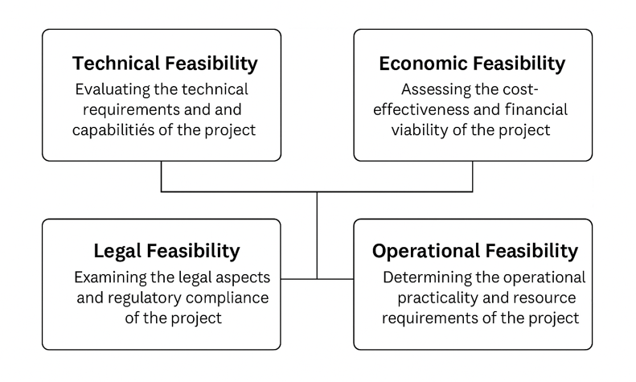

**Fig 3.4.1: Feasibility Study**



# CHAPTER – 4 METHODOLOGY



## 4. METHODOLOGY

### SYSTEM ARCHITECTURE

**Fig 4.1: System Architecture**

1. **Data Collection and Encryption:**
   * Initially, the data is collected from the user via signup process. The collected data from IoT devices is first transmitted to an edge server
   * The data is encrypted using AES (Advanced Encryption Standard) and Extension ECC (Elliptic Curve Cryptography).
   * This ensures confidentiality, data integrity, and lightweight encryption for resource constrained IoT devices.
2. **Blockchain Integration:**

The encrypted IoT data is then transmitted to the blockchain, which is:

* Integrated with cloud infrastructure for storage and scalability of data.
* Using Ethereum technology with platforms like Ganache (local test blockchain) and MetaMask (wallet for blockchain transactions)

1. **Data Indexing & Searching:**

* LSH (Locality Sensitive Hashing) is used to hash similar data points into buckets. It enables fast and approximate nearest neighbour search.
* Applied in the cloud layer to allow for efficient searching of encrypted IoT data without compromising privacy.
* This methodology is particularly effective for handling Large scale data, High dimensional data features.

1. **Data Request and Retrieval Workflow:**

Data Requesters (another IoT device or system):

* Send a search query to the cloud.
* The cloud uses the LSH algorithm to efficiently locate relevant IoT data.
* The matched and encrypted data is then returned to the requester.
  1. **WORKING PROCESS OF MODULES**
     1. **User Signup:** This module allows the new users to register with the application. During the signup process, user details are collected and securely saved on the blockchain, ensuring the integrity and authenticity of user information.
     2. **Cloud IoT User Login:** This module enables registered users to log in to the system. It verifies the credentials entered by the user against the information stored in the blockchain, ensuring secure access to the platform.
     3. **Data Owner File IoT Upload:** Users can upload files through this module. Upon uploading, a hash code is generated for signing, which is then verified using the blockchain to check the integrity of the file



* + 1. **LSH Data User Search:** This module allows users to perform keyword searches. Users enter search keywords, and the Edge server employs the LSH algorithm to quickly locate relevant results, returning the top files with the nearest matches based on similarity.
    2. **Propose Efficiency Graph:** This module generates graphs that illustrate the efficiency of various processes within the system, including execution times for the signing algorithm key setup, signing messages, and verifying messages.
    3. **Extension Efficiency Graph:** This module visualizes the execution time for search operations using the proposed LSH search method alongside the cache memory extension. It compares the search times, highlighting the benefits of cache in speeding up retrieval operations.

# 

# CHAPTER – 5

# SYSTEM REQUIREMENTS AND SPECIFICATIONS



## 5.SYSTEM REQUIREMENTS AND SPECIFICATIONS

### 5.1 HARDWARE REQUIREMENTS

* Processor - i5 & Above
* RAM - 8 GB & Above
* Hard Disk - 20 GB in local drive

###### 5.2 SOFTWARE REQUIREMENTS

* Operating System - Window 10 or above
* Programming Language - Python, JavaScript, MySQL
* Python libraries - Web3.py, numpy, eth-account

### PYTHON

Python is a high-level, interpreted programming language known for its simplicity and readability, making it a popular choice for beginners and professionals alike. Guido van Rossum created Python in the late 1980s, and its development is now overseen by the Python Software Foundation. One of Python's key features is its clean and easy-to- understand syntax, which emphasizes readability and reduces the cost of program maintenance. It supports multiple programming paradigms, including procedural, object-oriented, and functional programming. Python's extensive standard library provides support for a wide range of tasks, from web development and data analysis to artificial intelligence and scientific computing. Additionally, Python has a vast ecosystem of third-party libraries and frameworks, such as Django for web development, NumPy for numerical computing, and TensorFlow for machine learning. Python's dynamic typing and automatic memory management contribute to its flexibility and ease of use. It runs on various platforms, including Windows, macOS, and Linux, and is widely used in industries such as finance, technology, and academia. Overall, Python's versatility, simplicity, and large community make it an excellent choice for developing a wide range of applications.



### PYTHON INTERPRETER

Python executes the code line by line i.e., Python is an interpreter language. As we know the computer can’t understand our language, it can only understand the machine language i.e., binary language. So, the Python interpreter converts the code written in python language by the user to the language which computer hardware or system can understand. It does all the time whenever you run your python script. The Python interpreter first reads the command, then evaluates the command, prints the results, and then again loops it back to read the command and because of this only Python is known as REPL i.e., (Read, Evaluate, Print, Loop).

**5.2.3 HISTORY OF PYTHON**

* Python was developed by Guido Van Rossum in the late eighties and early nineties at the National Research Institute for Mathematics and Computer Science in the Netherlands.
* Python is derived from many other languages, including ABC, Modula-3, C, C++, Algol-68, Smalltalk, and Unix shell and other scripting languages.
* Python is copyrighted. Like Perl, Python source code is now available under the GNU General Public License (GPL).
* Python is now maintained by a core development team at the institute, although Guido van Rossum still holds a vital role in directing its progress**.**

### FEATURES OF PYTHON

* + 1. **Easy to Learn and Use:** Python is easy to learn as compared to other programming languages. Its syntax is straightforward and much the same as the English language. There is no use of the semicolon or curly-bracket, the indentation defines the code block. It is the recommended programming language for beginners.
    2. **Expressive Language:** Python can perform complex tasks using a few lines of code. A simple example, the hello world program you simply type print ("Hello World")**.** It will take only one line to execute, while Java or C takes multiple lines.



* + 1. **Easy to Learn and Use:** Python is easy to learn as compared to other programming languages. Its syntax is straightforward and much the same as the English language. There is no use of the semicolon or curly-bracket, the indentation defines the code block. It is the recommended programming language for beginners.
    2. **Expressive Language:** Python can perform complex tasks using a few lines of code. A simple example, the hello world program you simply type print ("Hello World")**.** It will take only one line to execute, while Java or C takes multiple lines.
    3. **Interpreted Language:** Python is an interpreted language; it means the Python program is executed one line at a time. The advantage of being interpreted language, it makes debugging easy and portable.
    4. **Cross-platform Language:** Python can run equally on different platforms such as Windows, Linux, UNIX, and Macintosh, etc. So, we can say that Python is a portable language. It enables programmers to develop the software for several competing platforms by writing a program only once.

### PYTHON LIBRARIES

**web3.py**: For interacting with Ethereum blockchain (smart contracts, transactions).

**OpenCV (cv2):** A comprehensive computer vision library offering a wide range of image and video processing functionalities.

**eth-account:** Ethereum account management, signing and key handling.

**Requests:** To send HTTP data between devices, edge nodes, and cloud.

**eth-utils:** Utilities for hashing, encoding, and formatting Ethereum data.



**5.2.6 MySQL**

MySQL is a widely-used open-source Relational Database Management System (RDBMS) that utilizes Structured Query Language (SQL) for database operations. Developed by MySQL AB and now owned by Oracle Corporation, MySQL is known for its reliability, speed, and ease of use. It is a key component in many web applications, forming the backbone of popular websites and services**.**

* + 1. **Key Features of MySQL**

MySQL offers several features that make it a popular choice for managing relational databases:

* + 1. **Open Source:** MySQL is free to use and has a large community of developers contributing to its improvement.
    2. **Open Source:** MySQL is free to use and has a large community of developers contributing to its improvement.
    3. **Relational:** It follows the relational database model, organizing data into tables with rows and columns.
    4. **Reliability:** Known for its stability and reliability, MySQL has been around for a long time.
    5. **Performance:** Optimized for performance, capable of handling high-volume transactions and large datasets efficiently.
    6. **Scalability:** Can scale both vertically and horizontally to accommodate growing data and user loads.
    7. **Compatibility:** Widely supported by many programming languages, frameworks, and tools.
    8. **Security:** Provides robust security features to protect data, including access controls, encryption, and auditing capabilities

**5.2.8 How MySQL Works**

MySQL operates through a series of steps to process and execute queries:

1. **Client Request:** A request is sent to the MySQL server using an application or a command line tool.
2. **Connection:** The server connects with the application to start a session.



**3. SQL Parsing:** The server checks the SQL query for any errors.

**4. Query Optimization:** The server determines the most efficient way to execute the query.

**5. Execution:** The server runs the query, reading or writing data to the database as needed.

**6. Storage Engine:** Data is stored on the disk using different storage engines.

**7. Result Generation:** The server creates the result based on the query.

**8. Response:** The server sends the results back to the application.

**9. Client Interaction:** The application displays the data to the user.

**10. Transaction Management:** Ensures smooth and accurate data operations for complex queries.

**11. Logging and Recovery:** Keeps logs to help recover data if something goes wrong.

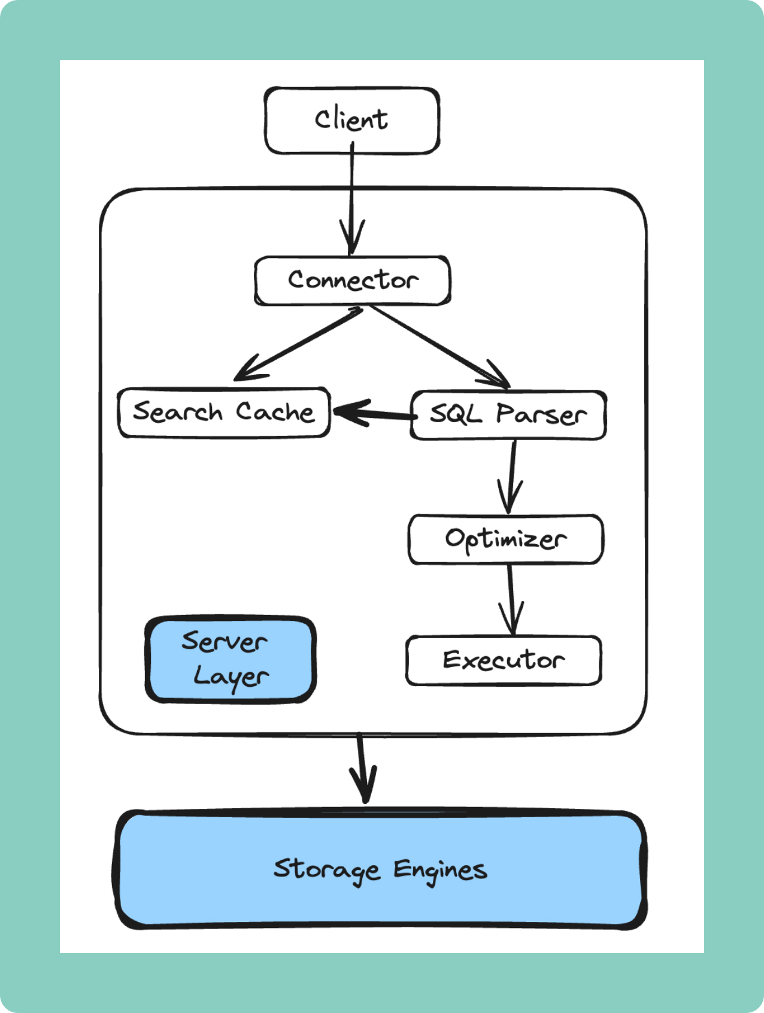**12. Replication and Backup:** Copies data to other servers for safety and better performance, and supports data backups.

**Fig 5.2.8.1 : Working Process of MySQL**



# CHAPTER – 6 SYSTEM DESIGN



## 6. SYSTEM DESIGN

### UML DIAGRAMS

* UML stands for Unified Modelling Language. UML is a standardized general- purpose modeling language in the field of object-oriented software engineering. The standard is managed, and was created by, the Object Management Group.
* The goal is for UML to become a common language for creating models of object- oriented computer software. In its current form UML is comprised of two major components: a Meta-model and a notation. In the future, some form of method or process may also be added to or associated with UML.

###### Why do we need UML?

* + Complex applications need collaboration and planning from multiple teams and hence require a clear and concise way to communicate amongst them.
  + Businessmen do not understand code. So UML becomes essential to communicate with non-programmers about essential requirements, functionalities, and processes of the system.
  + A lot of time is saved down the line when teams can visualize processes, user interactions, and the static structure of the system.

#### Building blocks of the UML:

The vocabulary of the UML encompasses three kinds of building blocks.

1. Things
2. Relationships
3. Diagrams

#### Things in the UML:

Things are the abstractions that are first-class citizen in a model. There are four kinds of things in the UML.

* 1. Structure Things.
  2. Behavioural Things
  3. Grouping Things.
  4. Annotational Things.

#### Relationships in the UML:

Things can be connected to logically are physically with the help of relationship in object oriented modelling. These are four kinds of relationships in the UML.

* 1. Dependency.
  2. Association.
  3. Generalization.
  4. Realization.

#### Diagrams in the UML:

A diagram is a graphical representation of a set of elements

* Use-case diagram
* Sequence diagram
* Class diagram
* Collaboration diagram
* Workflow diagram

## 6.1.1 SEQUENCE DIAGRAM

A sequence diagram in Unified Modelling Language (UML) is a kind of interaction diagram that shows how processes operate with one another and in what order.

A sequence diagram simply depicts interaction between objects in a sequential order such that the order in which these interactions take place. Sequence diagrams describe how and in what order the objects in a system function. These diagrams are widely used by software developers to document and understand requirements for new and existing systems. High level interactions between user of the system and the system, between the system and other systems, or between subsystems sometimes known as system sequence diagrams. Sequence diagrams are sometimes called event diagrams, event scenarios, and timing diagrams. The sequence diagram represents the flow of messages in the system and is also termed as an event diagram. It helps in envisioning several dynamic scenarios.

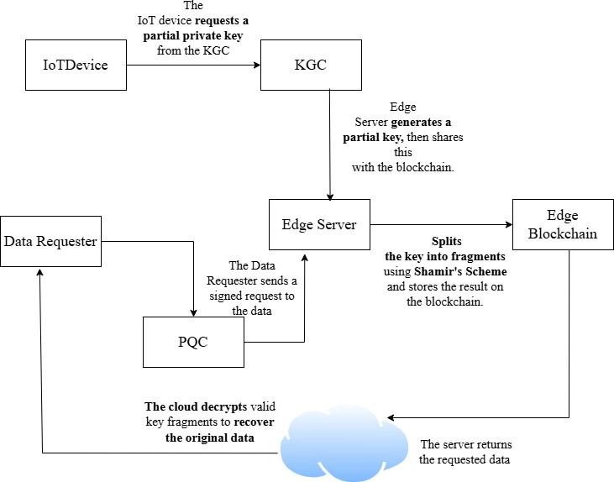

**Fig 6.1.1 Sequence Diagram**

## CLASS DIAGRAM

The class diagram depicts a static view of an application. It represents the types of objects residing in the system and the relationships between them. A class consists of its objects, and also it may inherit from other classes. A class diagram is used to visualize, describe, document various different aspects of the system, and also construct executable software code. It shows the attributes, classes, functions, and relationships to give an overview of the software system. It constitutes class names, attributes, and functions in a separate compartment that helps in software development. Since it is a collection of classes, interfaces, associations, collaborations, and constraints, it is termed as a structural diagram.



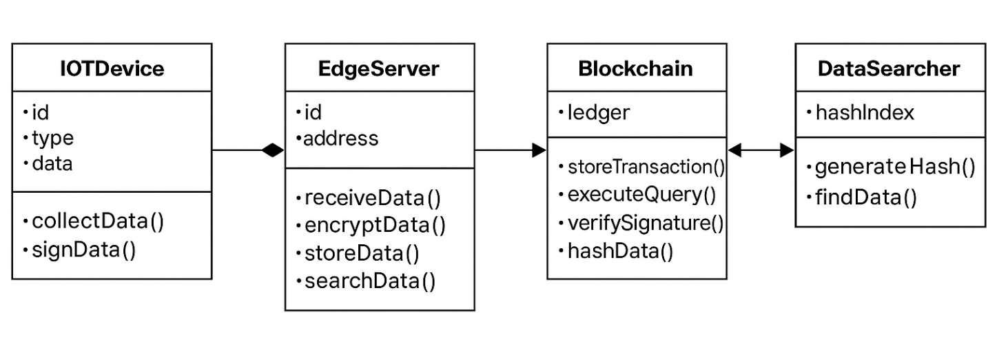

**Fig 6.1.2 : Class Diagram**

## ACTIVITY DIAGRAM

A Activity diagram (also known as a workflow) provides a graphic overview of the business process. Using standardized symbols and shapes, the workflow shows step by step how your work is completed from start to finish. It also shows who is responsible for work at what point in the process. Designing a workflow involves first conducting a thorough workflow analysis, which can expose potential weaknesses. A workflow analysis can help you define, standardize and identify critical areas of your process. An event is created as an activity diagram encompassing a group of nodes associated with edges. To model the behaviour of activities, they can be attached to any modeling element. It can model use cases, classes, interfaces, components, and collaborations. It mainly models processes and workflows. It envisions the dynamic behavior of the system as well as constructs a runnable system that incorporates forward and reverse engineering. It does not include the message part, which means message flow is not represented in an activity diagram.



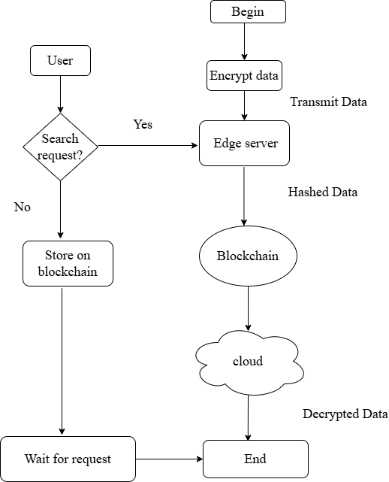

**Fig 6.1.3 : Activity Diagram**



# CHAPTER – 7 SYSTEM IMPLEMENTATION



## SYSTEM IMPLEMENTATION

## The implementation of the described system integrates blockchain, IoT, and advanced cryptographic techniques for secure data handling and efficient search. The User Signup and Login modules utilize blockchain to ensure secure registration and authentication, preserving data integrity. In the File Upload module, files are encrypted with AES and ECC algorithms, and signed using a bilinear hash code, guaranteeing data confidentiality and integrity, with hash codes stored on the blockchain for traceability. The Local Sensitive Hashing (LSH) Search module leverages LSH for efficient data retrieval, caching search results on the edge server to speed up subsequent queries. Efficiency Graphs showcase the execution times for signing, encryption, and search processes. The use of ECC enhances encryption efficiency for IoT devices, while Cache Memory stores previously searched queries, reducing computational load and improving search performance.

### SYSTEM MODULES

**1. IoT Device Module**

#### Role: Acts as both data owner and data requester.

#### Functions:

#### Collects raw data.

#### Encrypts and signs data.

#### Generates digests and indexes using hash and LSH.

#### Sends data to edge servers.

#### 2. Key Generation Center (KGC) Module

#### Role: Trusted authority for key management.

#### Functions:

#### Generates global parameters.

#### Issues master secret/public keys.

#### Generates partial private keys for devices.



**3. Edge Server Module**

**Role**: Middleware layer between IoT devices and the blockchain/cloud.

**Functions**:

* Verifies device authenticity via signature validation.
* Uploads verified data to cloud and metadata to blockchain.
* Stores symmetric key fragments using Shamir’s secret sharing.
* Handles data requests and responds with key fragments.

**4. Edge Blockchain Module**

**Role**: Immutable distributed ledger maintained by edge servers.

**Functions**:

* + - Stores digests, indexes, and search results.
    - Provides tamper-proof and decentralized data verification.
    - Ensures traceability of data access and search requests.

**5. Search Smart Contract Module**

**Role**: Search interface layer on blockchain.

**Functions**:

* Implements the LSH-based search algorithm.
* Matches requests with relevant indexed data.
* Logs matched data digests to the blockchain.

**6. Cloud Storage Module**

**Role**: Remote storage for ciphertext.

**Functions**:

* Stores encrypted data uploaded by edge servers.
* Monitors blockchain for search results.
* Forwards the matched ciphertext to the requesting IoT device.

# CHAPTER – 8 TESTING

**8. SYSTEM TESTING**

**8.1 SYSTEM TESTING**

System testing, also referred to as system-level testing or system integration testing, is the process in which a quality assurance (QA) team evaluates how the various components of an application interact together in the full, integrated system or application.

System testing verifies that an application performs tasks as designed. It's a type of black box testing that focuses on the functionality of an application rather than the inner workings of a system, which white box testing is concerned with.

**8.2 TYPES OF SYSTEM TESTING**

With system testing, a QA team gauges if an application meets all of its technical, business and functional requirements. To accomplish this, the QA team might utilize various types of software testing techniques that determine the overall test coverage for an application and help catch critical defects that hamper an application's core functionalities before release.

The following are the common types of system testing techniques:

* + 1. **Functional Testing:**

This verifies that each component and the overall system performs its intended functions correctly. It ensures that data is processed accurately, commands are executed as expected, and the system meets its functional requirements.

**8.2.2 Compatibility Testing:**

IoT devices often need to interact with various platforms, operating systems, and other devices. This testing ensures seamless interoperability across diverse environments.

#### 8.2.3 Performance Testing:

#### IoT systems generate vast amounts of data and must handle varying loads. Performance testing evaluates factors like

#### Latency

#### Throughput

#### Response time

#### Scalability

#### Stress testing.

#### 8.2.4 Connectivity Testing:

#### Connectivity testing validates Reliable communication is fundamental to IoT such as :

#### Network connectivity (Wi-Fi, Bluetooth)

#### Data transmission between devices and the cloud

#### Protocol functionality (MQTT)

#### Security Testing:

#### IoT devices are vulnerable to security threats. This Security testing focuses on:

#### Identifying vulnerabilities

#### Ensuring data encryption

#### Validating access controls

#### Penetration testing

**8.2.6 Usability Testing:**

Usability testing evaluates the user experience of interacting with IoT devices and applications. It assesses:

* Ease of use
* Interface design
* User-friendliness

**8.3 TEST CASES**

|  |  |  |
| --- | --- | --- |
| **S.NO** | **INPUT** | **RESULT** |
| 1 | User Signup | New users can register by storing details (Username, Password, Email, Place, Phone Number) securely on blockchain. |
| 2 | Cloud IoT User Login | Registered users can log in by means of verified credentials via blockchain. |
| 3 | Data Owner File IoT Upload | Users who successfully logged in can upload files, generating block and hash values encrypted with AES. |
| 4 | LSH Data User Search | Users can retrieve the uploaded data via Edge server. |
| 5 | Propose Efficiency Graph | Generates line graphs displaying the process of execution times and performance benefits. |
| 6 | Extension Efficiency Graph | Visualizes search operation times, comparing LSH method with cache. |

# CHAPTER – 9 RESULTS



### RESULTS

The execution of the process will be explained clearly with the help of continuous screenshots.

**Fig 1: Activating Ganache Workspace**

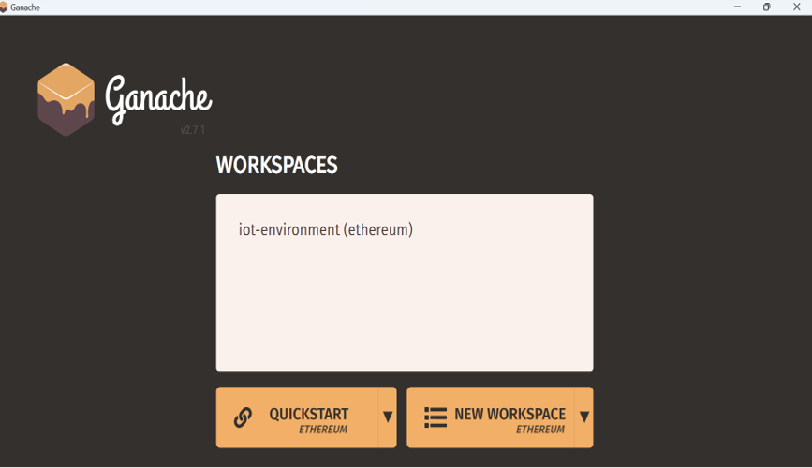

**Result of Fig 1 : Interface after activating workspace**

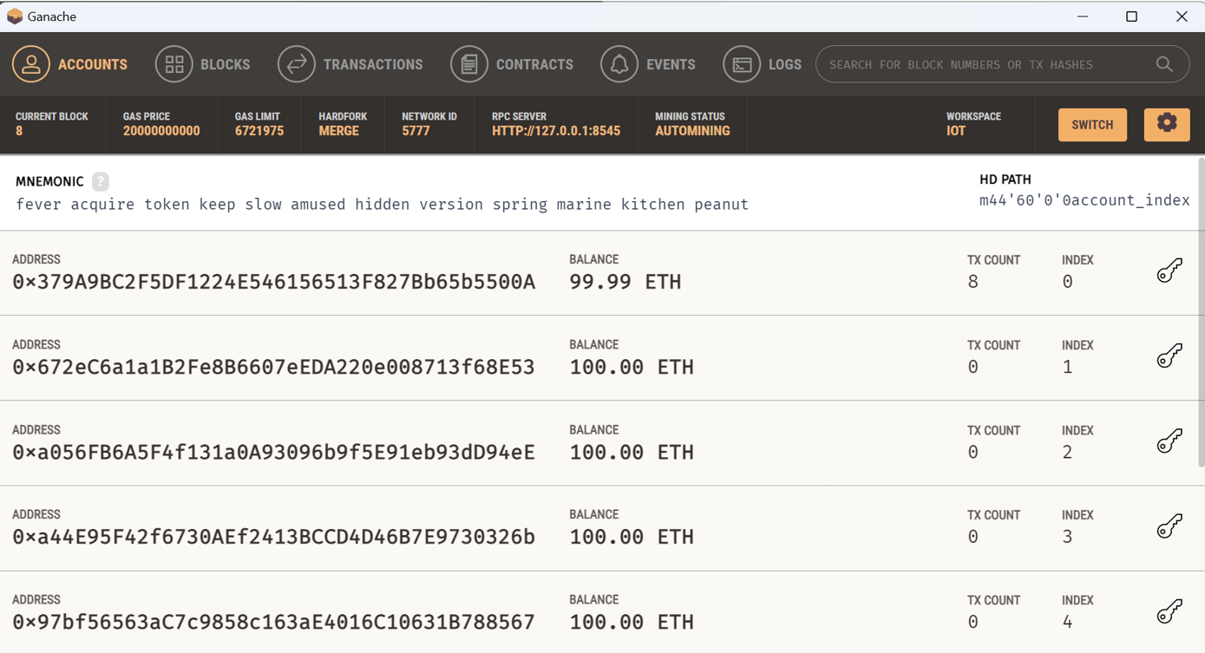



**Blocks in Ganache Fig 1, Before Executing other Steps**

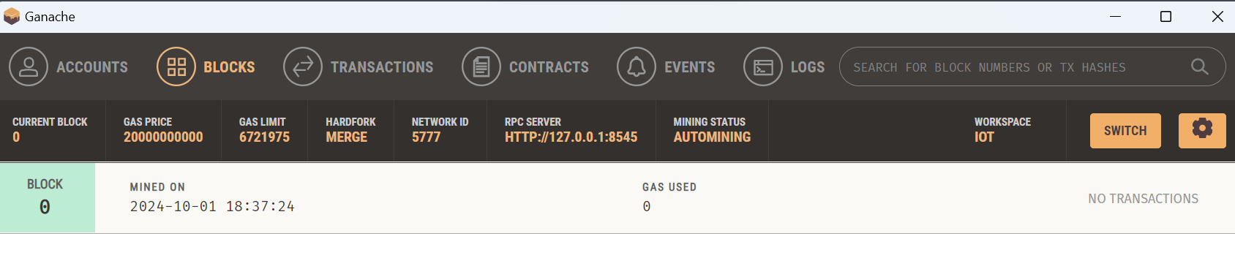

**Fig 2: Folder Path**

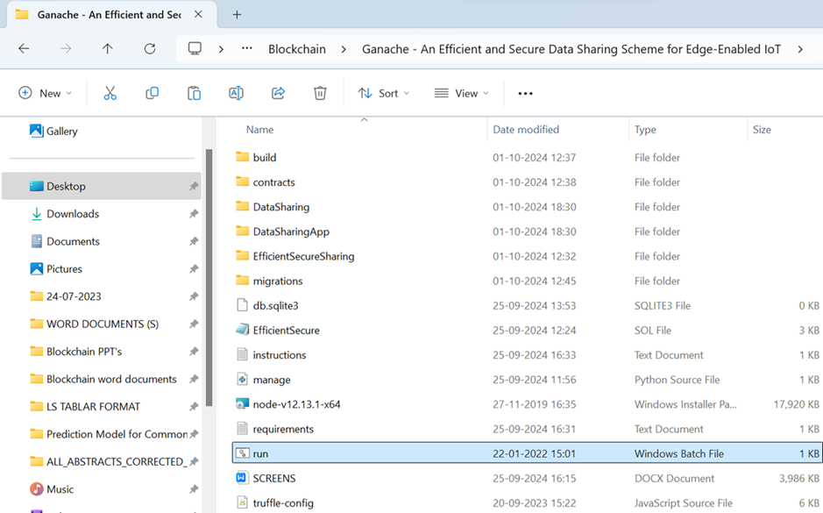



**Result of Fig 2**

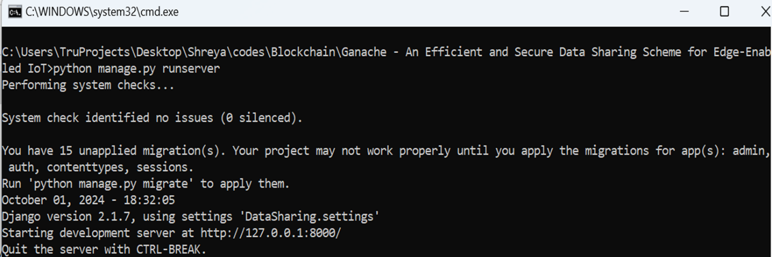

**Fig 3 : Copy the Ip address from cmd**

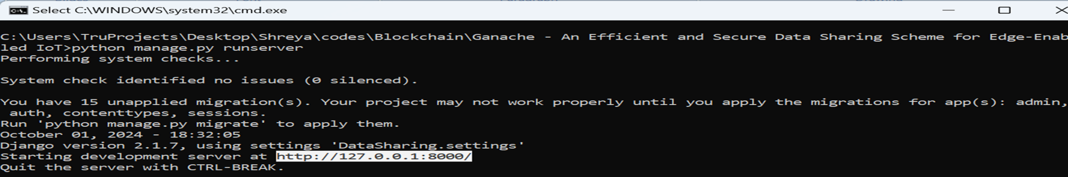

**Fig 4 : Dump the Ip address in the browser**

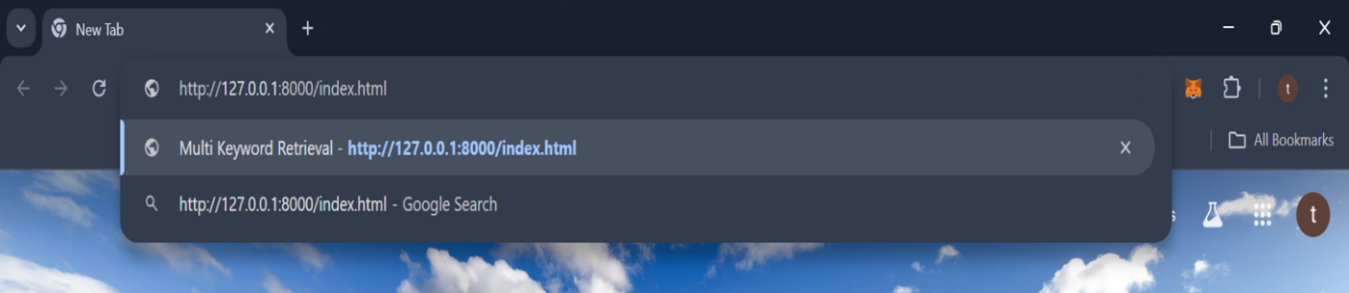

**User Inter Face after executing Fig 4**

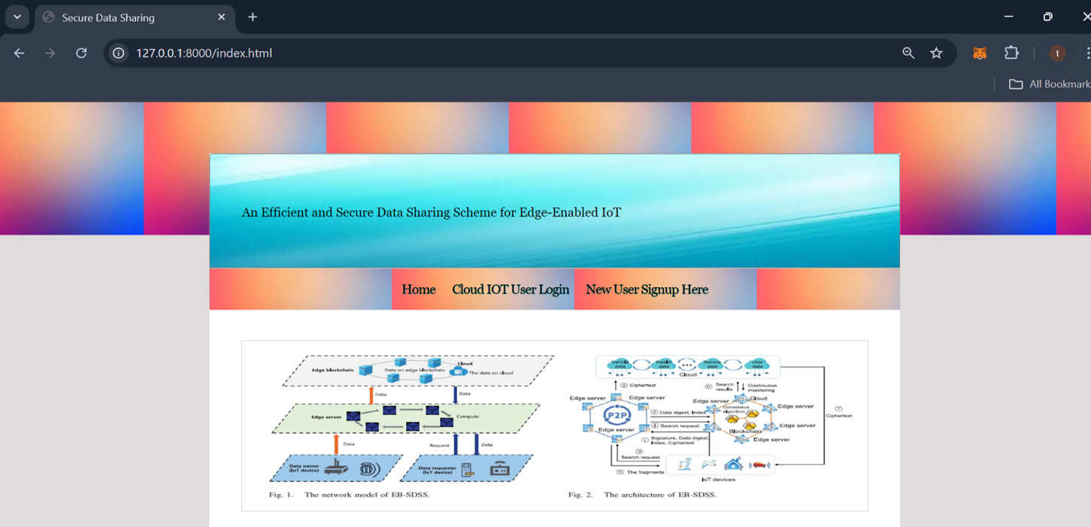

**Fig 5 : New User can Signup**

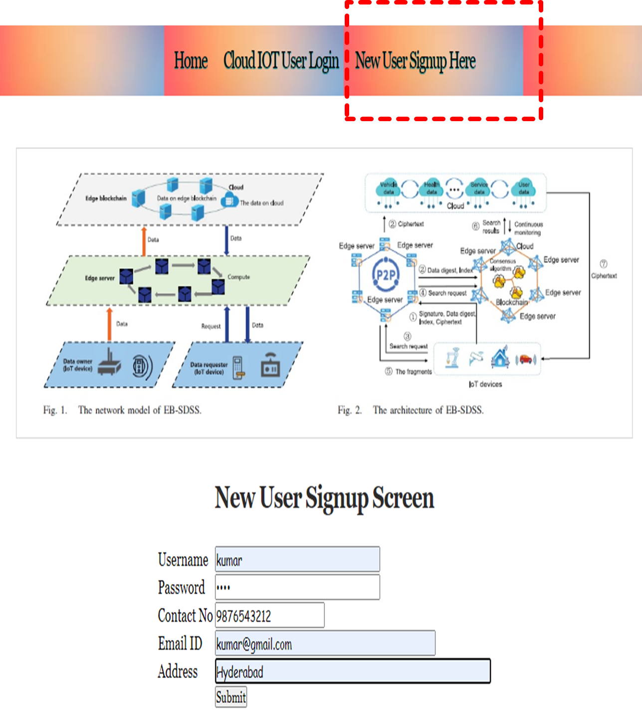

**Result of Fig 5**

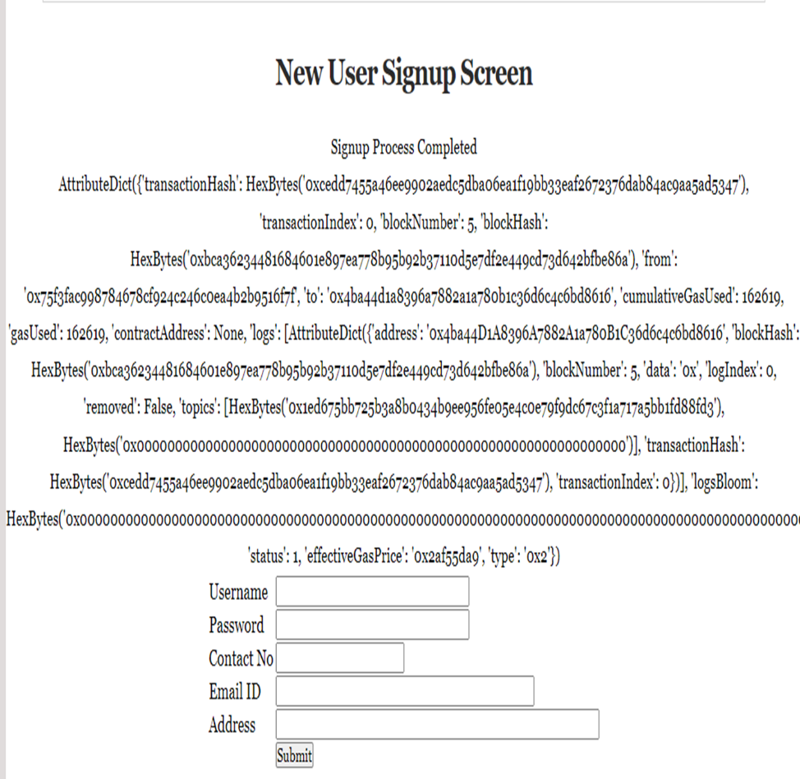

**Blocks in Ganache up to execution**

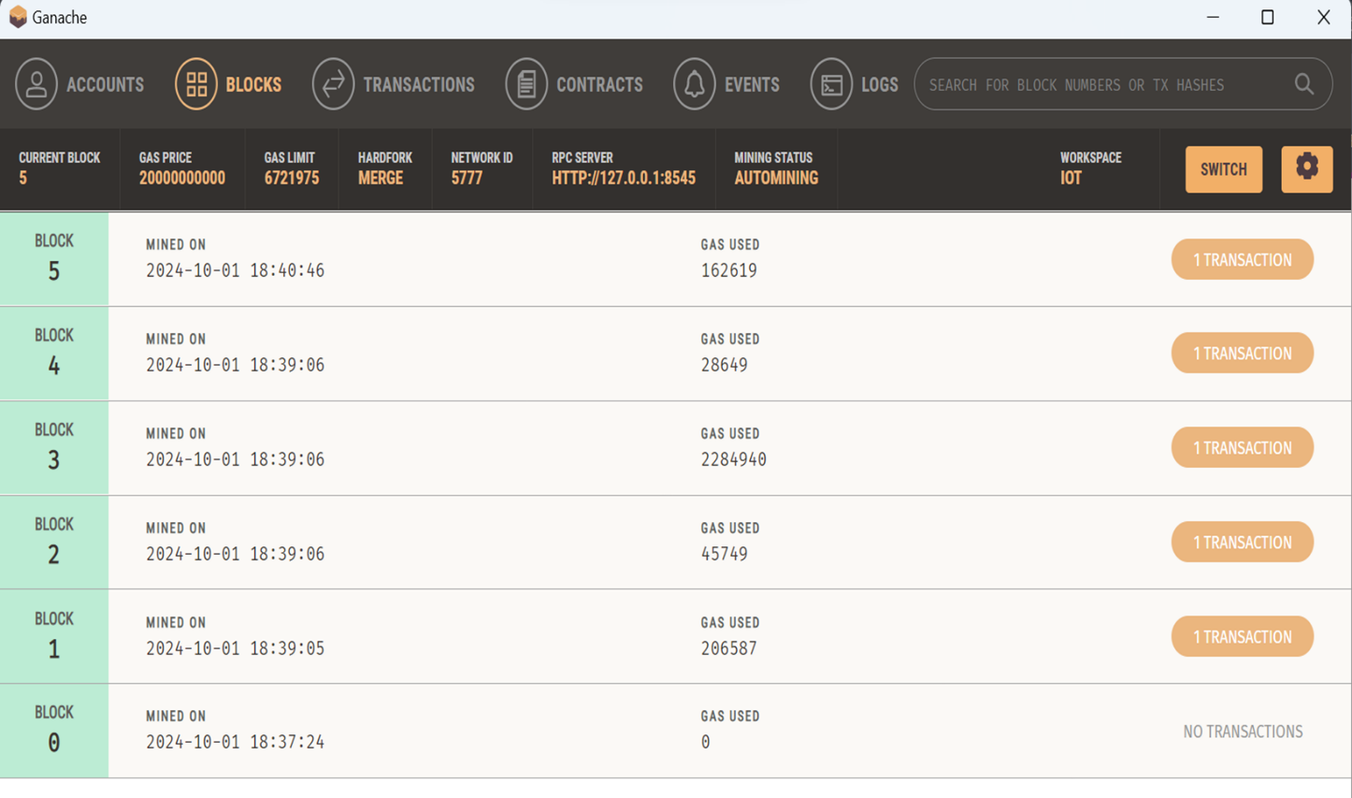

**Fig 6 : User Login**

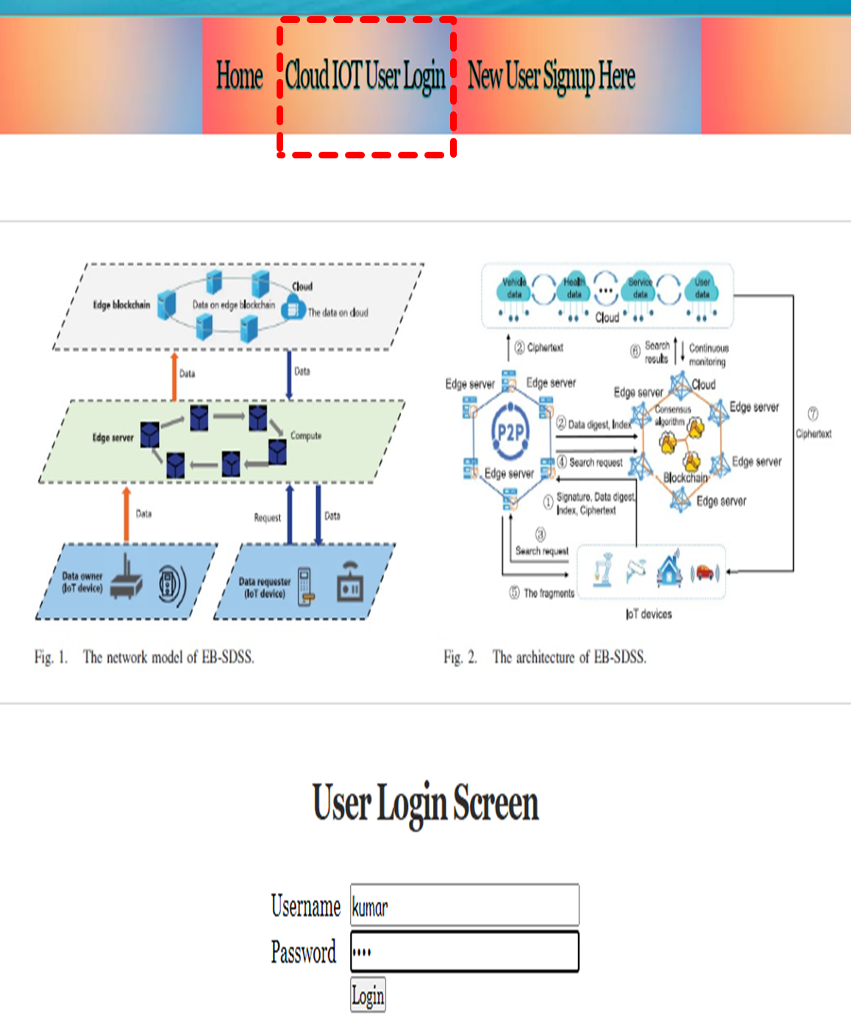

**User Dashboard**

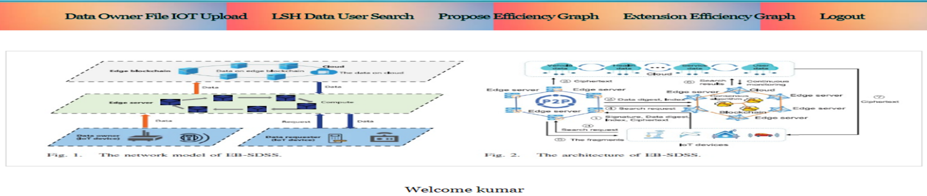

**Fig 7: Uploading Files**

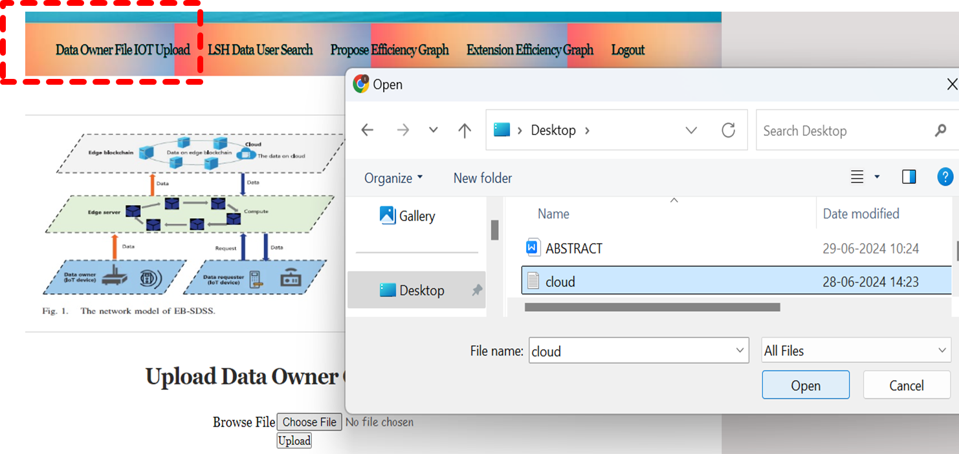

**Result of Fig 7**

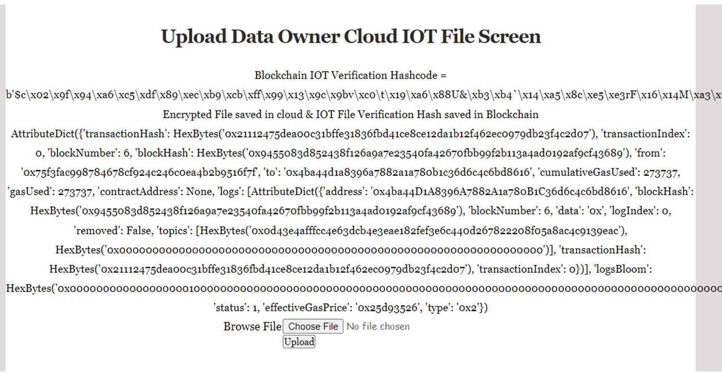

**Fig 8 : Searching Data by using LSH**

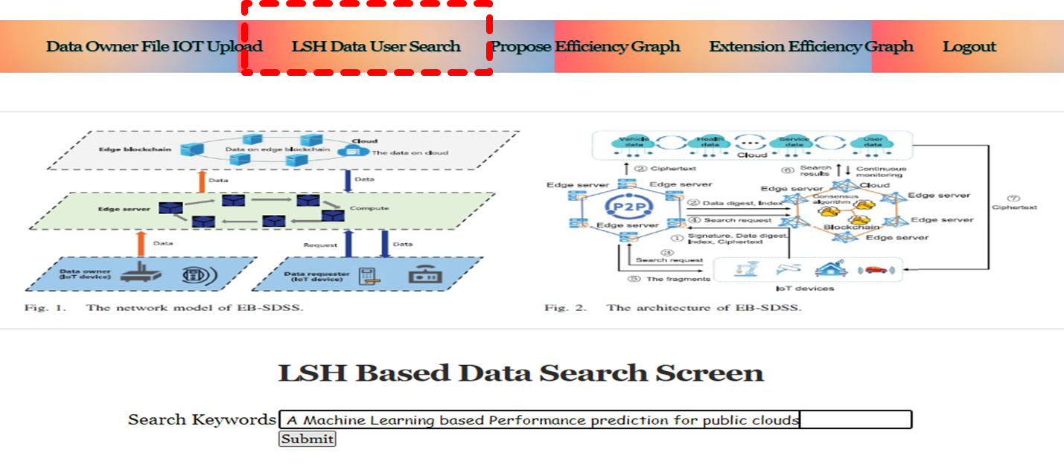

**Fig 9 : Retrieval of Data**

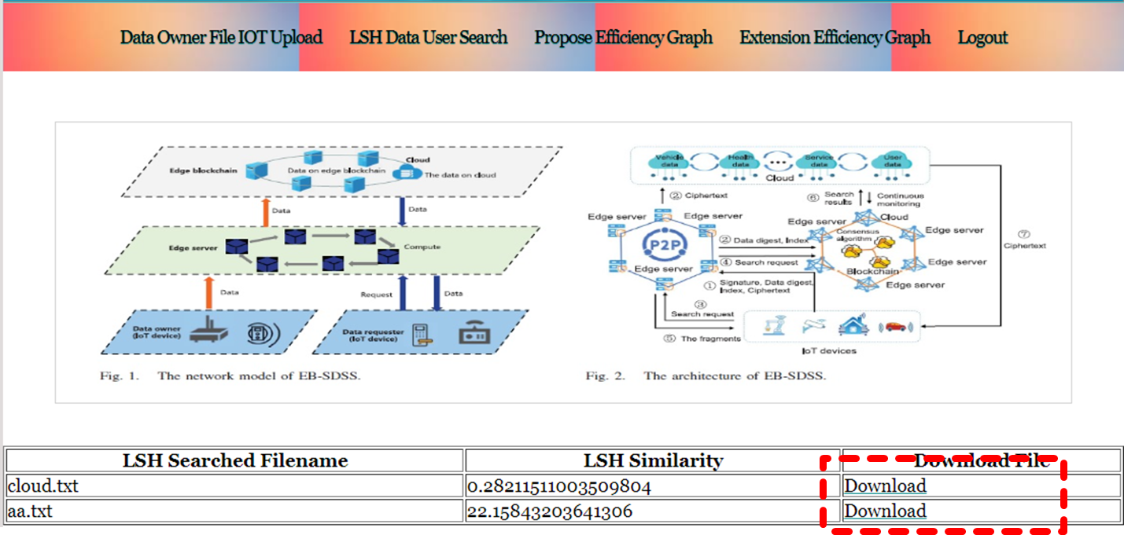

**Fig 10 : Propose Efficiency Graph**

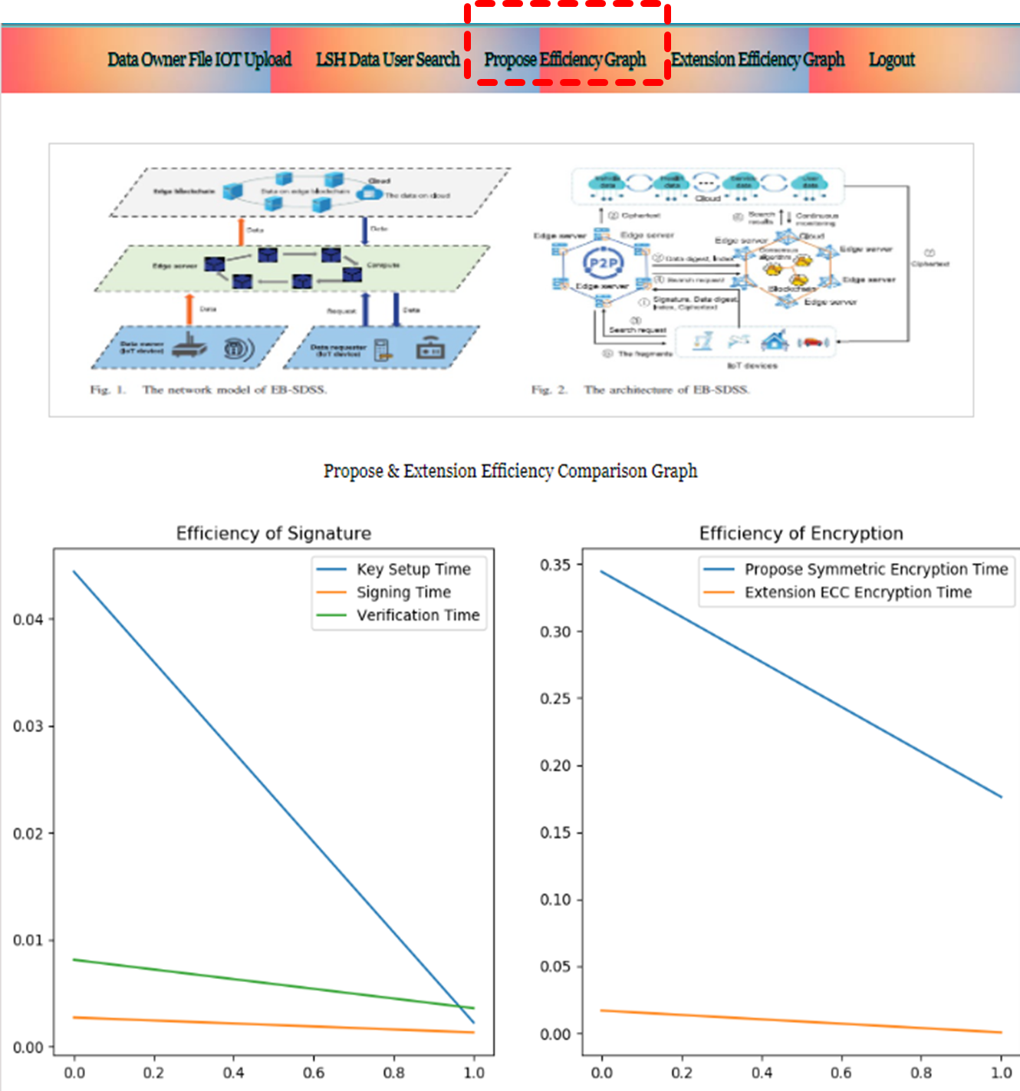

**Fig 11 : Extension Efficiency Graph**

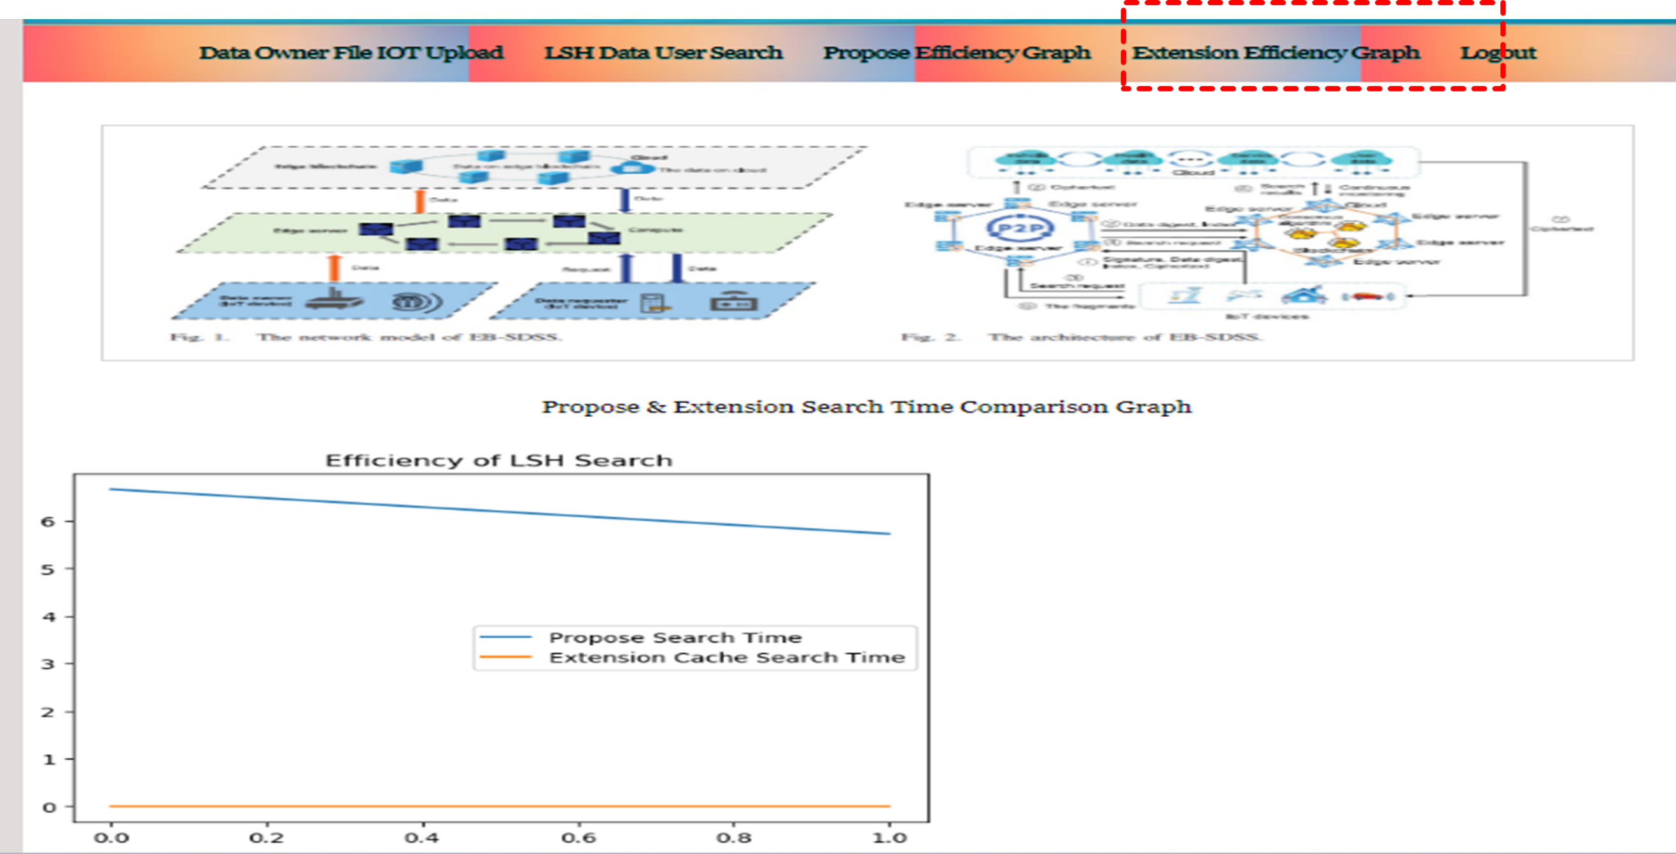

# CHAPTER – 10 CONCLUSION

## CONCLUSION

The integration of blockchain technology ensures tamper-proof storage and verification of data, fostering trust and integrity in the information shared among IoT devices. Utilizing edge servers closer to IoT devices minimizes data transfer time to cloud servers, significantly improving the responsiveness and performance of the system. The project employs Local Sensitive Hashing (LSH) and caching techniques to streamline data retrieval processes, allowing for quick access to relevant information and reducing the computational load. Implementing certificate-less signature schemes within the blockchain framework enhances device authentication, ensuring reliable data sharing and integrity across the network. The project employs both AES symmetric encryption and lighter alternatives like Elliptic Curve Cryptography (ECC), which takes less execution time. This combination balances strong encryption with performance efficiency in data sharing for edge-enabled IoT environments.

# CHAPTER – 11 FUTURE SCOPE

## FUTURE SCOPE

Future developments could focus on scaling the system to accommodate a larger number of IoT devices and users, ensuring efficient data sharing and management as the IoT ecosystem continues to grow. Integration with AI and Machine Learning: Incorporating AI and machine learning techniques can improve data analysis, predictive maintenance, and decision-making processes in IoT environments, enhancing the overall user experience. Establishing interoperability with other blockchain networks could enable seamless data sharing and collaboration among different IoT systems, fostering a more connected and efficient ecosystem. Future iterations could focus on enhancing real-time data processing capabilities, allowing for immediate responses to events and conditions detected by IoT devices, thereby improving operational efficiency in various applications.

# CHAPTER – 12 BIBILIOGRAPHY

## BIBLIOGRAPHY

[1] J. Cui, F. Ouyang, Z. Ying, L. Wei and H. Zhong, "Secure and efficient data sharing among vehicles based on consortium blockchain", IEEE Trans. Intell. Transp. Syst., vol. 23, no. 7, pp. 8857-8867, Jul. 2022.

[2] G. Manogaran, M. Alazab, P. M. Shakeel and C.-H. Hsu, "Blockchain assisted secure data sharing model for Internet of Things based smart industries", IEEE Trans. Rel., vol. 71, no. 1, pp. 348-358, Mar. 2022.

[3] K. Yu, L. Tan, M. Aloqaily, H. Yang and Y. Jararweh, "Blockchain-enhanced data sharing with traceable and direct revocation in IoT", IEEE Trans. Ind. Informat., vol. 17, no. 11, pp. 7669-7678, Nov. 2021.

[4] Y. Lu, X. Huang, Y. Dai, S. Maharjan and Y. Zhang, "Blockchain and federated learning for privacy-preserved data sharing in industrial IoT", IEEE Trans. Ind. Informat., vol. 16, no. 6, pp. 4177-4186, Jun. 2020.

[5] X. Zheng and Z. Cai, "Privacy-preserved data sharing towards multiple parties in industrial IoTs", IEEE J. Sel. Areas Commun., vol. 38, no. 5, pp. 968-979, May 2020.

[6] J. Xie et al., "A survey of blockchain technology applied to smart cities: Research issues and challenges", IEEE Commun. Surveys Tuts., vol. 21, no. 3, pp. 2794-2830, 2019.

[7] R. Chaudhary, A. Jindal, G. S. Aujla, S. Aggarwal, N. Kumar and K.-K. R. Choo, "BEST: Blockchain-based secure energy trading in SDN-enabled intelligent transportation system", Comput. Secur., vol. 85, pp. 288-299, Aug. 2019.

[8] L. Chen, W.-K. Lee, C.-C. Chang, K.-K. R. Choo and N. Zhang, "Blockchain based searchable encryption for electronic health record sharing", Future Gener. Comput. Syst., vol. 95, pp. 420-429, Jun. 2019.

[9] A. Jindal, G. S. Aujla and N. Kumar, "Survivor: A blockchain based edge-as-a-service framework for secure energy trading in SDN-enabled vehicle-to-grid environment", Comput. Netw., vol. 153, pp. 36-48, Apr. 2019.

[10] B. Cui, Z. Liu and L. Wang, "Key-aggregate searchable encryption (KASE) for group data sharing via cloud storage", IEEE Trans. Comput., vol. 65, no. 8, pp. 2374-2385, Aug. 2016.

[11] R. Yang, F. R. Yu, P. Si, Z. Yang and Y. Zhang, "Integrated blockchain and edge computing systems: A survey some research issues and challenges", IEEE Commun. Surveys Tuts., vol. 21, no. 2, pp. 1508-1532, 2019.